Figure S7 Kinetic changes of IC molecule expression by eTreg cells in both PBMCs and TILs.

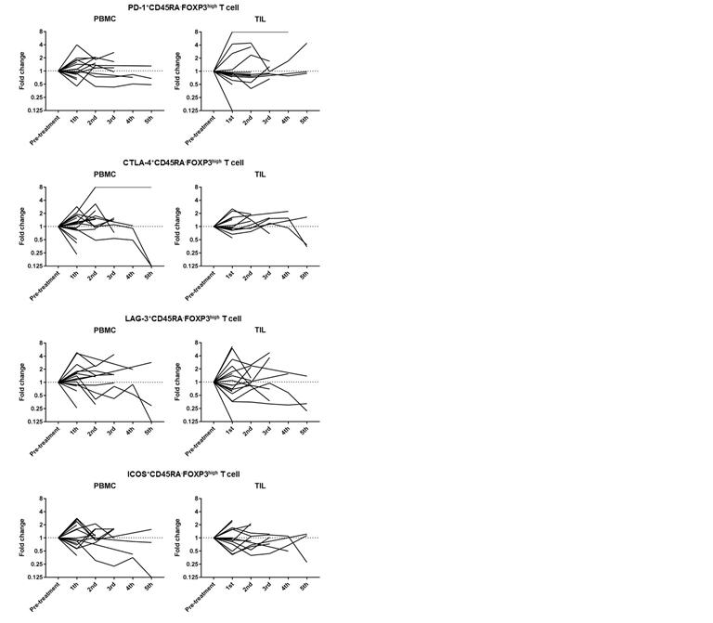
Pre- and post-treatment TILs and PBMCs were collected and were subjected to flow cytometry to analyze immune profiles in detail. Kinetic changes of IC molecule expression by eTreg cells exhibited dynamic changes.

