Figure S1 Genomic features of patients with GC who received RAM-containing therapies.
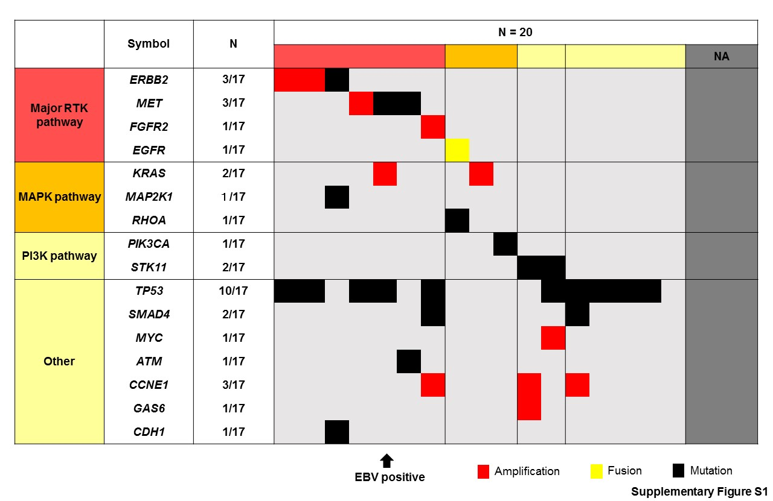DNA and RNA were extracted from FFPE tumor samples before treatment and were subjected to the Oncomine™ Comprehensive Assay version 3 to detect gene mutations, copy number variants and fusions across multiple genes. TP53 were frequently mutated (10/17) and ERBB2, MET, FGFR2, or KRAS, amplification, or a RHOA mutation were also identified. In contrast, all were MMR proficient GC and only one was EBV-positive GC (an arrow). RTK, receptor tyrosine kinase; NA, not available.

