Figure S3 Kinetic changes of eTreg cells and PD-1 expression by CD8⁺ T cells according to therapies in TILs.
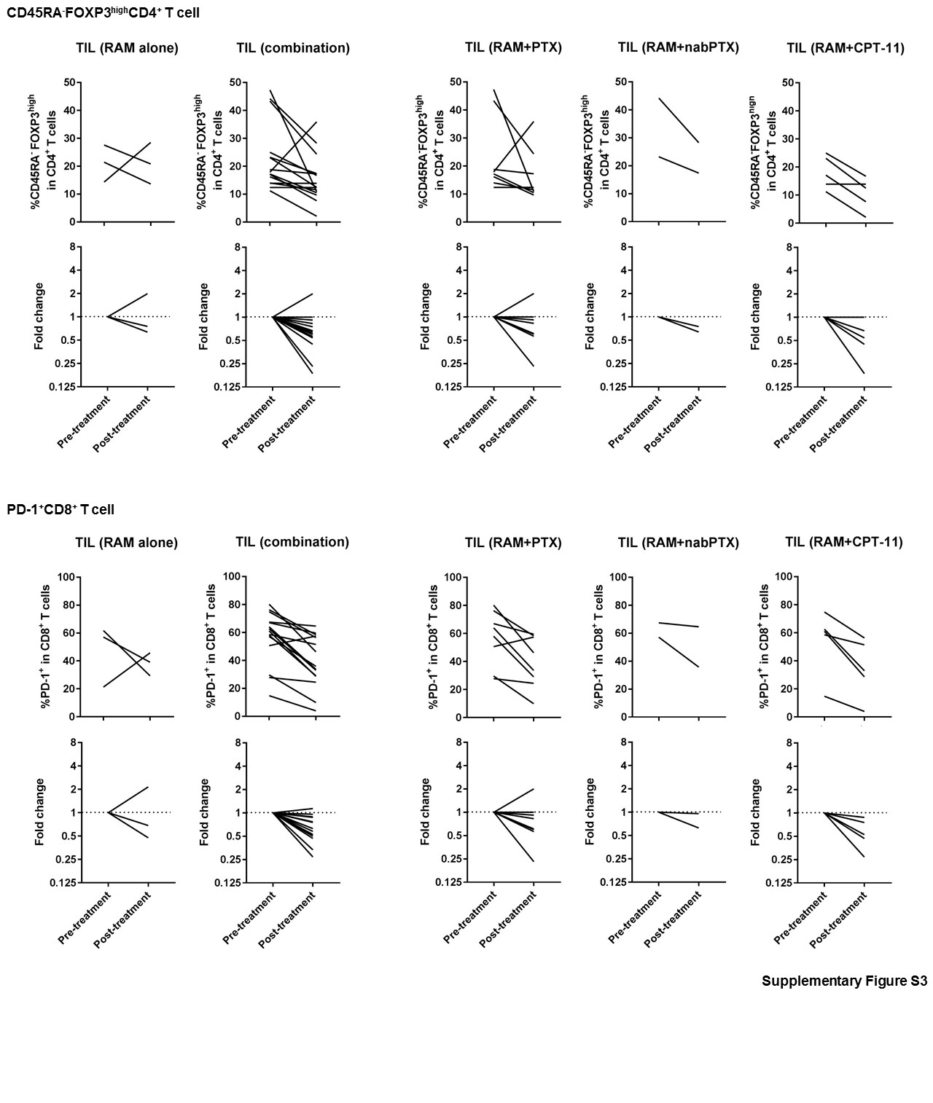
Pre- and post-treatment TILs were collected and were subjected to flow cytometry to analyze immune profiles in detail. The tendencies of reduction were observed in both RAM monotherapy and RAM with chemotherapy including RAM+PTX, RAM+nabPTX, or RAM+CPT-11.

