Figure S6 Kinetic changes of IC molecule expression by CD45RA⁻FOXP3⁻CD4⁺ T cells in both PBMCs and TILs.
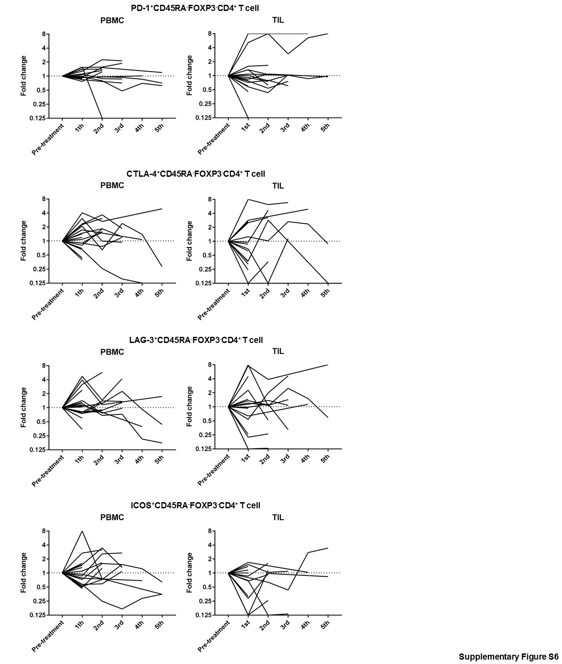 Pre- and post-treatment TILs and PBMCs were collected and were subjected to flow cytometry to analyze immune profiles in detail. Kinetic changes of IC molecule expression by CD45RA⁻FOXP3⁻CD4⁺ T cells exhibited dynamic changes.

