Additional file 2

Figure S1. Characterization of TRAPs from tumor cell lines or cancer patients. a-c Characterization of B16F10 TRAPs. a Flow cytometry analysis of LC3B on TRAPs. b Western blot analysis of LC3-II for parental cells and TRAPs. c TEM images of TRAPs. Scale bar, 1 μm, 0.2 μm, 100 nm (from left to right). d-f Characterization of TRAPs derived from cancer patients. d Flow cytometry analysis of LC3B on TRAPs. e Western blot analysis of LC3-II for TRAPs from HepG2 cells and cancer patients. f TEM images of TRAPs. Scale bar, 1 μm, 0.2 μm, 100 nm (from left to right). Results are representative of three independent experiments.

Figure S2. Phenotype determination of BMDMs stimulated by TRAPs with different doses and origin. a BMDMs were stimulated with TRAPs at indicated doses for 48 h. PD-L1 was evaluated by flow cytometry, and (b) IL-10 was measured by ELISA. c TRAPs were cultured with Raw264.7, peritoneal macrophage and BMDMs, respectively. PD-L1 and (d) IL-10 was detected after 48 h. e BMDMs were treated with TRAPs from EL4, B16F10, Hepa1-6 or 4T1 cells for 48 h, followed by assessment of PD-L1 and (f) IL-10. Data (mean ± SEM) are representative of three independent experiments. ***p < 0.001 by unpaired t test (d and f).

Figure S3. TRAPs treated BMDMs inhibit T cell proliferation. a CFSE-labeled T cells were left untreated or were activated in the presence of plate-bound anti-CD3 plus soluble anti-CD28 mAb and were either cultured alone or were incubated with control or TRAPs (10 μg/ml) stimulated BMDMs at indicated ratios (20:1, 20:2 and 20:4). Cells were harvested after 72 h, and T cells division was analyzed by flow cytometry. b BMDMs were loaded with peptide SIINFEKL (1 μg/ml) for 2 h, washed, and were then cocultured with B3Z cells for 18 h at a ratio of 1:3, in the presence of anti-PD-L1 (10 μg/ml), anti-IL-10 (10 μg/ml), or IgG isotype control (10 μg/ml). B3Z T cell activation was measured by CPRG assay. Data are representative of three independent experiments. *p < 0.05, **p < 0.01 and ***p < 0.001 by unpaired t test (a and b).

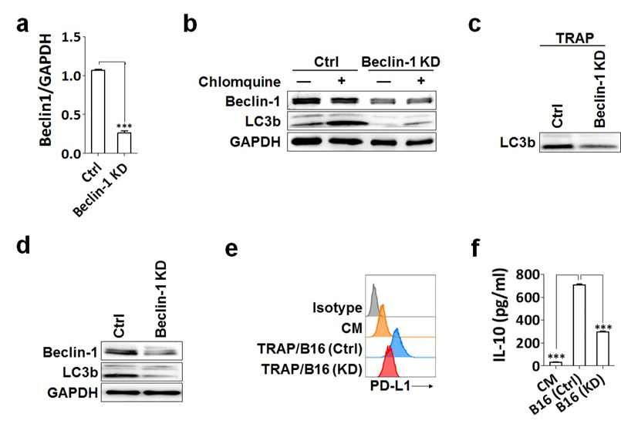

Figure S4. Genetic inhibition of autophagy by targeting Beclin1 reduces TRAPs production. a qRT-PCR analysis of Beclin1 mRNA expression in B16F10 (Ctrl) and B16F10 (BECN1 KD) cells. b Tumor cells were treated with or without chlomquine (30 μM) for 24 h, lysates were detected for Beclin1 and LC3B expression by western blot. c TRAPs were obtained from equal number of B16F10 (Ctrl) and B16F10 (BECN1 KD) cells, suspended in same volume of PBS, then were detected for LC3-II by western blot. d Lysates from resected tumors were assessed for Beclin1 and LC3B by western blot (n = 6 per group). e, f BMDMs were treated with TRAPs from equal number of BECN1-KD B16F10 (B16 KD) and Ctrl-B16F10 (B16 Ctrl) cells for 24 h, expression of PD-L1 and IL-10 was detected by flow cytometry and ELISA, respectively. Data are representative of three independent experiments.

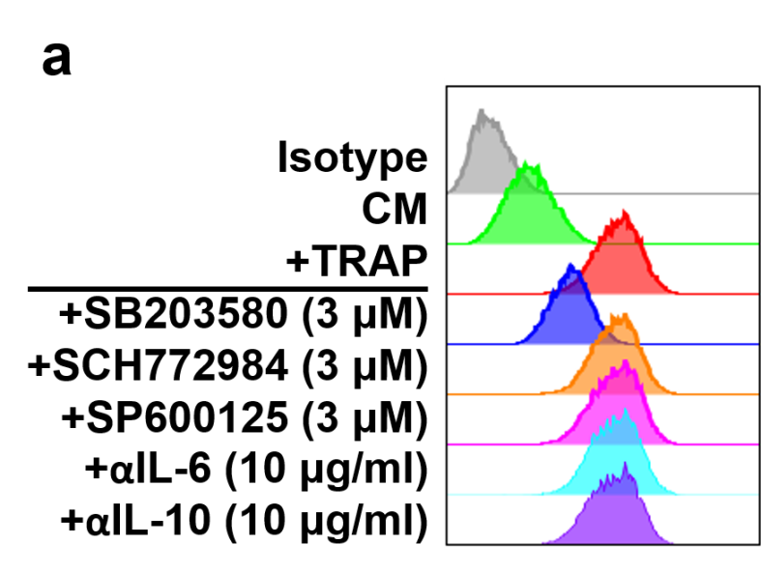

Figure S5. TRAPs induced PD-L1 upregulation on BMDMs was mainly dependent on p38 activation. a BMDMs were preincubated with p38 inhibitor SB203580 (3 μM), Erk1/2 inhibitor SCH772984 (3 μM), JNK inhibitor SP600125 (3 μM), anti-IL-6 mAb (10 μg/ml) and anti-IL-10 mAb (10 μg/ml) for 1 h, and then treated with TRAPs (10 μg/ml) for 48 h. Expression of PD-L1 was determined by flow cytometry.

Figure S6. Comparison of LC3B⁺ EVs and LC3B⁻ EVs in converting monocytes. a LC3B⁺ EVs and LC3B⁻ EVs were sorted from total EVs of a lung cancer patient, and LC3B expression was determined by flow cytometry. b-d Purified CD14⁺ monocytes from healthy donors were treated for 3 d with total EVs, LC3B⁺ EVs, LC3B⁻ EVs (5 μg/ml) and magnetic beads, respectively. Expression of CD163, HLA-DR, CD86 (b) and PD-L1 (c) was detected by flow cytometry. IL-10 production (d) in the supernatant was assessed by ELISA.

