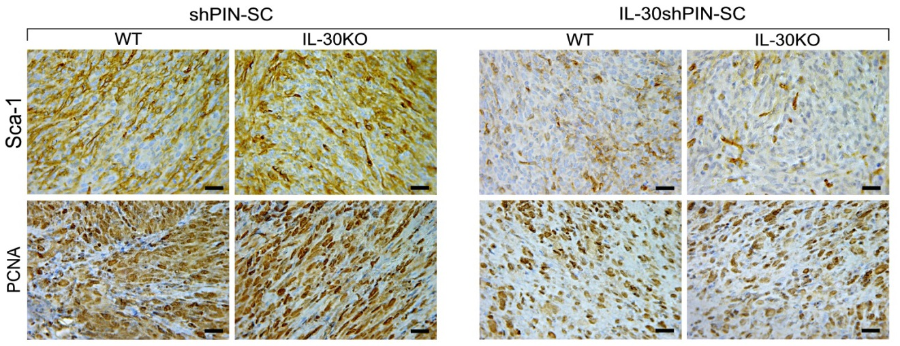

Figure S1. Sca-1 and PCNA immunostainings in shPIN-SC and IL-30shPIN-SC tumors developed in WT and IL-30KO mice. Magnification: X400. Scale bars: 30 μm.

Figure S2. IL-30 immunostaining in the spleen of WT and IL-30KO mice. Magnification: X400. Scale bars: 30 μm.

