Supplemental Figure 1

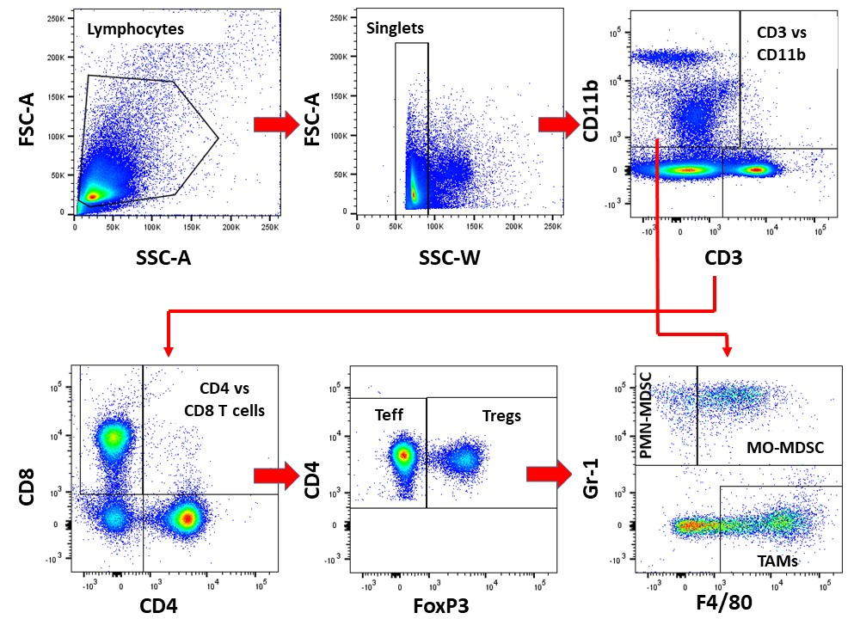

cytometry data was collected on a BD Fortessa Dual cytometer, compensated in FlowJo 7.65 and gated and analyzed in FlowJo 10.5. Representative data is shown to illustrate profiling of major T cell and myeloid populations from B16-F10 tumors.

