Supplemental Materials

Supplemental Tables

Supplemental Table S1. Lower limits of quantification (LLOQ) of analyte (data from ThermoFisher†).
Analyte | LLOQ*
BTLA | 144.65
CD27 | 5.76
CD28 | 42.02
CD80 | 43.58
CD137/4-1BB | 14.21
CD152/CTLA4 | 9.52
GITR | 27.2
HVEM | 18.55
IDO | 4.37
LAG-3 | 11.21
PD-1 | 7.13
PD-L1 | 3.64
PD-L2 | 48.71
TIM-3 | 63.18
* in pg/mL;
† ProcartaPlex Human Immuno-Oncology Checkpoint Panel, https://www.thermofisher.com/order/catalog/product/EPX14A-15803-901

Supplement table S2. Real-time PCR probes for T cell immune checkpoint gene expression used in this study
Gene name | Official full name | Probe number | Catalog number
BTLA | B and T lymphocyte associated (BTLA) | Hs00699198_m1 | 4331182
CD27 | CD27 molecule (CD27) | Hs00609654_g1 | 4351372
CD28 | CD28 molecule (CD28) | Hs00155512_m1 | 4331182
CD3E | CD3e molecule(CD3E) | Hs01062241_m1 | 4331182
CD274 | CD274 molecule (CD274) | Hs00204257_m1 | 4331182
CTLA4 | cytotoxic T-lymphocyte associated protein 4(CTLA4) | Hs00175480_m1 | 4331182
HAVCR2 | hepatitis A virus cellular receptor 2(HAVCR2) | Hs00958618_m1 | 4331182
IDO1 | Indoleamine 2,3-dioxygenase 1 (IDO1) | Hs00699198_m1 | 4331182
LAG3 | lymphocyte activating 3(LAG3) | Hs00958444_g1 | 4351372
PDCD1 | programmed cell death 1(PDCD1) | Hs01550088_m1 | 4331182
PDCD1LG2 | Programmed cell death 1 ligand 2 (PDCD1LG2) | Hs00228839_m1 | 4331182
TNFRSF14 | TNF receptor superfamily member 14 (TNFRSF14) | Hs00998605_g1 | 4331182
TNFRSF9 | TNF receptor superfamily member 9 (TNFRSF9) | Hs00155512_m1 | 4331182
GAPDH | glyceraldehyde-3-phosphate dehydrogenase(GAPDH) | Hs01548420_m1 | 4331182
*All probes were purchased from Applied Biosystems, Waltham, MA

Supplemental Table S3. Covariates of unconditional logistic regression model, multivariate Cox proportional hazard model for recurrence and survival
Covariates |  | Model for  tumor stage Coef.(95%CI)* |  | P value |  | Model for recurrence  Coef.(95%CI)** |  | P value |  | Model for  survival Coef.(95%CI)*** |  | P value
Sex | -0.04(-0.72-0.65) |  | 0.92 |  | 0.41 (-0.11-0.94) |  | 0.12 |  | -1.22 (-2.40--0.04) |  | 0.04
Age | 0.01 (-0.02-0.05) |  | 0.41 |  | -0.03 (-0.05-0.002) |  | 0.07 |  | 0.05 (0.001-0.09) |  | 0.04
Smoking status
Former | -0.12 (-0.75-0.51) |  | 0.71 |  | -0.06 (-0.59-0.47) |  | 0.82 |  | -1.05 (-1.98--0.12) |  | 0.03
Current | -0.08 (-1.25-1.08) |  | 0.89 |  | 0.73 (-0.04-1.50) |  | 0.06 |  | 0.53 (-0.57-1.63) |  | 0.35
BMI | -0.01 (-0.06-0.04) |  | 0.62 |  | -0.03 (-0.07-0.007) |  | 0.11 |  | -0.07 (-0.14--0.004) |  | 0.04
Hypertension | -0.10 (-0.83-0.63) |  | 0.79 |  | 0.03 (-0.52-0.59) |  | 0.91 |  | 0.06 (-0.94-1.06） |  | 0.91
Diabetes | 0.17 (-0.63-0.96) |  | 0.68 |  | -0.37 (-0.94-0.20) |  | 0.2 |  | -1.08 (-1.97--0.19) |  | 0.02
Histology | NA |  | NA |  | 0.39 (-0.27-1.04) |  | 0.25 |  | 0.49 (-0.61-1.60) |  | 0.38
Stage | NA |  | NA |  | 1.98 (1.42-2.54) |  | 0 |  | 0.92 (0.15-1.70) |  | 0.02
Tumor grade† | NA |  | NA |  | 0.49 (0.30-0.67) |  | 0 |  | 0.27 (-0.03-0.56) |  | 0.08
Treatment‡ | NA |  | NA |  | -0.04 (-0.71-0.64) |  | 0.92 |  | -0.14 (-1.20-0.92) |  | 0.79
*: covariates of unconditional logistic regression model for tumor stage;
**: covariates of multivariate Cox proportional hazard model for recurrence;
***covariates of multivariate Cox proportional hazard model for survival.
† Tumor grade based on Fuhrman criteria.
‡indicate adjuvant chemotherapy

Supplemental Table S4. Circulating levels of soluble immune checkpoint proteins in ccRCC patients
 | Early Stage^{c} |  |  |  | Late Stage^{c}
Marker | No |  | Median (IQR) pg/ml |  | No | Median (IQR) pg/ml |  | P value | cutoff^{b}
sBTLA | 76 |  | 144.65 (144.65-852.02) |  | 82 | 144.65 (144.65-469.94) |  | 0.48 | 2269
sCD27 | 87 |  | 350.64 (192.04-753.37) |  | 90 | 307.57 (179.93-595.62) |  | 0.47 | 1029
sCD28 | 75 |  | 42.02 (42.02-149.34) |  | 76 | 42.02 (42.02-138.74) |  | 0.86 | 42.68
sCD80ª | 83 |  | 43.58 (43.58-43.58) |  | 86 | 43.58 (43.58-43.58) |  | 0.54 | 43.58
sCD137ª | 77 |  | 14.21 (14.21-14.21) |  | 82 | 14.21 (14.21-14.21) |  | 0.96 | 110.2
sCTLA4 | 76 |  | 24.78 (9.52-61.01) |  | 80 | 33.14 (9.52-66.64) |  | 0.32 | 33.14
sGITRª | 79 |  | 27.20 (27.20-27.20) |  | 85 | 27.20 (27.20-27.20) |  | 0.71 | 27.2
sHVEMª | 85 |  | 18.55 (18.55-18.56) |  | 85 | 18.55 (18.55-18.56) |  | 0.45 | 18.55
sIDO | 76 |  | 4.37 (4.37-18.33) |  | 75 | 4.37 (4.37-12.96) |  | 0.73 | 4.37
sLAG3 | 86 |  | 139.98 (81.58-216.34) |  | 90 | 160.55 (103.70-206.76) |  | 0.18 | 258
sPD1ª | 88 |  | 7.13 (7.13- 7.13) |  | 91 | 7.13 (7.13- 7.13) |  | - | -
sPDL1 | 73 |  | 7.26 (3.64-21.67) |  | 75 | 7.85 (3.64-19.72) |  | 0.94 | 13.37
sPDL2 | 85 |  | 1381.38 (48.71-5328.93) |  | 87 | 1348.71(48.71-6132.34) |  | 0.92 | 3032
sTIM3 | 87 |  | 3628.83 (2713.02-5176.08) |  | 90 | 4226.43 (2962.89-5696.84) |  | 0.16 | 5908
Abbreviations: ccRCC, clear cell renal cell carcinoma; IQR, interquartile range.
ª CD137, HVEM, GITR, CD80 and PD1 level demonstrated few variations, thus these markers were not included in the subsequent analysis.
^{b} Levels of all soluble biomarkers and immune checkpoint genes were dichotomized into low- and high-level groups using a logistic regression spline model (12).
^{c} Early stage indicates stage I&II disease, Late stage indicate stage III disease, the staging criteria according to NCCN guideline 2019 v.2.0.

Supplemental Table S5. Association with sTIM3 with death risk of ccRCC patients stratified by clinical stage
Protein name | Early stage (I & II) |  |  | Late stage (III)
High vs low* | Adjusted HR (95%CI)† | P value |  | Adjusted HR (95%CI)† | P value
sTIM3 | 1 (reference) |  |  | 1 (reference)
 | 36.14 (3.733-350) | 1.95E-03# |  | 1.62 (0.60-4.41) | 0.34
Abbreviations: ccRCC, clear cell renal cell carcinoma; HR, hazard ratio; CI confidence interval.
Significant values in bold font.
* High- and low-level groups dichotomized by the logistic regression spline model (12).
† Adjusted by age, gender, smoking, BMI, diabetes, hypertension, histology, grade, and treatment.
# Significant after Bonferroni adjustment for multiple testing.

Supplemental Table S6. Risk scores of soluble immune checkpoint biomarkers for ccRCC survival
Risk score * | Dead | Alive | HR (95% CI)† | P value | MST (month) | P log-rank
Low | 11 (9.02) | 111 (90.98) | 1 (reference) |  | -
Medium | 8 (30.77) | 18 (69.23) | 3.29 (1.14-9.52) | 0.028 | -
High | 14 (41.18) | 20 (61.11) | 12.88 (3.62-45.78) | 7.88E-05 | 22.4 | 5.14E-11
Abbreviations: ccRCC, clear cell renal cell carcinoma; HR, hazard ratio; CI, confidence interval; MST, median survival time.
* Risk groups were divided into tertiles based on levels of sBTLA and sTIM3.
† Adjusted by age, gender, smoking, BMI, diabetes, hypertension, histology, grade, stage and treatment.
(-) MST greater than follow-up time.

Supplemental Table S7: The correlation between circulating checkpoint level and T cell functions
 |  | CD8A |  |  | CYT score 1† |  |  | CYT score 2† |  |  | IFNG
Markers | N | rho | P |  | rho | P |  | rho | P |  | rho | P
sTIM3 | 46 | -0.17 | 0.26 |  | -0.14 | 0.35 |  | 0.00 | 0.99 |  | -0.10 | 0.50
sCD28 | 38 | -0.25 | 0.14 |  | -0.33 | 0.05* |  | -0.33 | 0.05* |  | -0.07 | 0.67
sCD137 | 40 | 0.16 | 0.33 |  | 0.04 | 0.80 |  | 0.04 | 0.80 |  | -0.03 | 0.83
sCD27 | 45 | -0.06 | 0.72 |  | 0.01 | 0.96 |  | 0.17 | 0.27 |  | 0.15 | 0.32
sCTLA4 | 39 | -0.05 | 0.75 |  | -0.08 | 0.65 |  | -0.02 | 0.89 |  | 0.28 | 0.08
sHVEM | 43 | -0.06 | 0.71 |  | -0.10 | 0.52 |  | -0.10 | 0.51 |  | -0.12 | 0.44
sIDO | 35 | -0.06 | 0.73 |  | -0.05 | 0.79 |  | -0.11 | 0.52 |  | 0.13 | 0.46
sLAG3 | 46 | -0.35 | 0.02 |  | -0.31 | 0.04 |  | -0.25 | 0.09 |  | -0.21 | 0.17
sBTLA | 39 | -0.05 | 0.76 |  | -0.09 | 0.59 |  | 0.07 | 0.68 |  | -0.05 | 0.75
sPD1 | 46 | 0.08 | 0.61 |  | 0.00 | 0.97 |  | -0.08 | 0.59 |  | -0.15 | 0.33
sPDL1 | 36 | 0.25 | 0.15 |  | 0.29 | 0.09 |  | 0.45 | 0.01 |  | 0.51 | 1.31E-03
sPDL2 | 43 | 0.05 | 0.76 |  | 0.11 | 0.49 |  | 0.18 | 0.24 |  | 0.19 | 0.22
* Before rounding, P=0.0464 and P=0.0459, respectively.
¹ Cytolytic score based on GZMA and PRF1 tissue expression.
² Cytolytic score based on GZMB and PRF1 tissue expression.

Supplemental Table S8. Tumor expression of immune checkpoint genes and association with ccRCC overall survival in the MDACC and TCGA cohorts
 |  | MDACC cohort (n=47) |  |  |  |  |  | TCGA cohort (n=382)#
Gene | Expression | Dead | Alive | HR (95%CI)* | P value | P log-rank |  | Dead | Alive | HR (95%CI) † | P value | P log-rank
BTLA | low | 7 (20.59) | 27 (79.41) | 1 (reference) |  |  |  | 49(25.65) | 142(74.35) | 1(reference)
 | high | 3 (23.08) | 10 (76.92) | 1.41 (0.27-7.46) | 0.69 | 0.25 |  | 43(22.51) | 148(77.49) | 0.73 (0.47-1.14) | 0.17 | 0.35
CD27 | low | 6(25.00) | 18(75.00) | 1 (reference) |  |  |  | 39(20.42) | 152(79.58) | 1(reference)
 | high | 4(17.39) | 19(82.61) | 0.27 (0.03-2.76) | 0.27 | 0.93 |  | 53(27.75) | 138(72.25) | 1.00(0.65-1.56) | 0.97 | 0.21
CD28 | low | 6(20.69) | 23(79.31) | 1 (reference) |  |  |  | 41(21.47) | 150(78.53) | 1(reference)
 | high | 4(22.22) | 14(77.78) | 1.08 (0.22-5.16) | 0.93 | 0.55 |  | 51(26.70) | 140(73.30) | 1.11 (0.72-1.71) | 0.63 | 0.47
CD274 | low | 7 (24.14) | 22 (75.86) | 1 (reference) |  |  |  | 59(30.89) | 132(69.11) | 1(reference)
 | high | 3 (16.67) | 15 (83.33) | 0.77 (0.13-4.59) | 0.78 | 0.48 |  | 33(17.28) | 158(82.72) | 0.51(0.33-0.80) | 3.23E-03 | 6.70E-04
CTLA4 | low | 7(21.88) | 25(78.13) | 1 (reference) |  |  |  | 39(20.42) | 152(79.58) | 1(reference)
 | high | 3(20.00) | 12(80.00) | 0.80(0.14-4.58) | 0.80 | 0.66 |  | 53(27.75) | 138(72.25) | 1.22 (0.78-1.89) | 0.38 | 0.05
HAVCR2 | low | 4(15.38) | 22(84.62) | 1 (reference) |  |  |  | 52(27.23) | 139(72.77) | 1(reference)
 | high | 6(28.57) | 15(71.43) | 5.79 (1.00-33.7) | 0.05 | 0.32 |  | 40(20.94) | 151(79.06) | 0.59(0.39-0.91) | 0.02 | 0.08
IDO1 | low | 5 (20.00) | 20 (80.00) | 1 (reference) |  |  |  | 41(21.47) | 150(78.53) | 1(reference)
 | high | 5 (22.73) | 17 (77.27) | 1.10 (0.20-6.14) | 0.91 | 0.54 |  | 51(26.70) | 140(73.30) | 0.94 (0.62-1.44) | 0.79 | 0.45
LAG3 | low | 6 (22.22) | 21 (77.78) | 1 (reference) |  |  |  | 35(18.32) | 156(81.68) | 1(reference)
 | high | 4 (20.00) | 16 (80.00) | 1.40 (0.20-10.0) | 0.74 | 0.70 |  | 57(29.84) | 134(70.16) | 1.14 (0.73-1.78) | 0.56 | 0.03
PDCD1 | low | 7 (21.21) | 26 (78.79) | 1 (reference) |  |  |  | 41(21.47) | 150(78.53) | 1(reference)
 | high | 3 (21.43) | 11 (78.57) | 0.98 (0.18-5.17) | 0.98 | 0.68 |  | 51(26.70) | 140(73.30) | 0.97 (0.62-1.51) | 0.89 | 0.28
PDCD1LG2 | low | 3 (10.34) | 26 (89.66) | 1 (reference) |  |  |  | 51(26.70) | 140(73.30) | 1(reference)
 | high | 7 (38.89) | 11 (61.11) | 8.62 (1.47-50.7) | 0.02 | 0.01 |  | 41(21.47) | 150(78.53) | 0.69 (0.44-1.06) | 0.09 | 0.17
TNFRSF14 | low | 6(20.69) | 23(79.31) | 1(reference) |  |  |  | 47(24.61) | 144(75.39) | 1(reference)
 | high | 4(22.22) | 14(77.78) | 3.85 (0.37-40.1) | 0.26 | 0.65 |  | 45(23.56) | 146(76.44) | 0.92 (0.60-1.42) | 0.72 | 0.79
TNFRSF9 | low | 5(21.74) | 18(78.26) | 1(reference) |  |  |  | 46(24.08) | 145(75.92) | 1(reference)
 | high | 5(20.83) | 19(79.17) | 0.39 (0.05-2.85) | 0.35 | 0.53 |  | 46(24.08) | 145(75.92) | 0.73 (0.47-1.16) | 0.14 | 0.95
* adjusted by age, gender, smoking, BMI, diabetes, hypertension, histology, grade and stage.
† adjusted by age, sex, grade, stage.
# Number of patients analyzed is less than total due to missing clinical outcome information.

Supplemental Figures

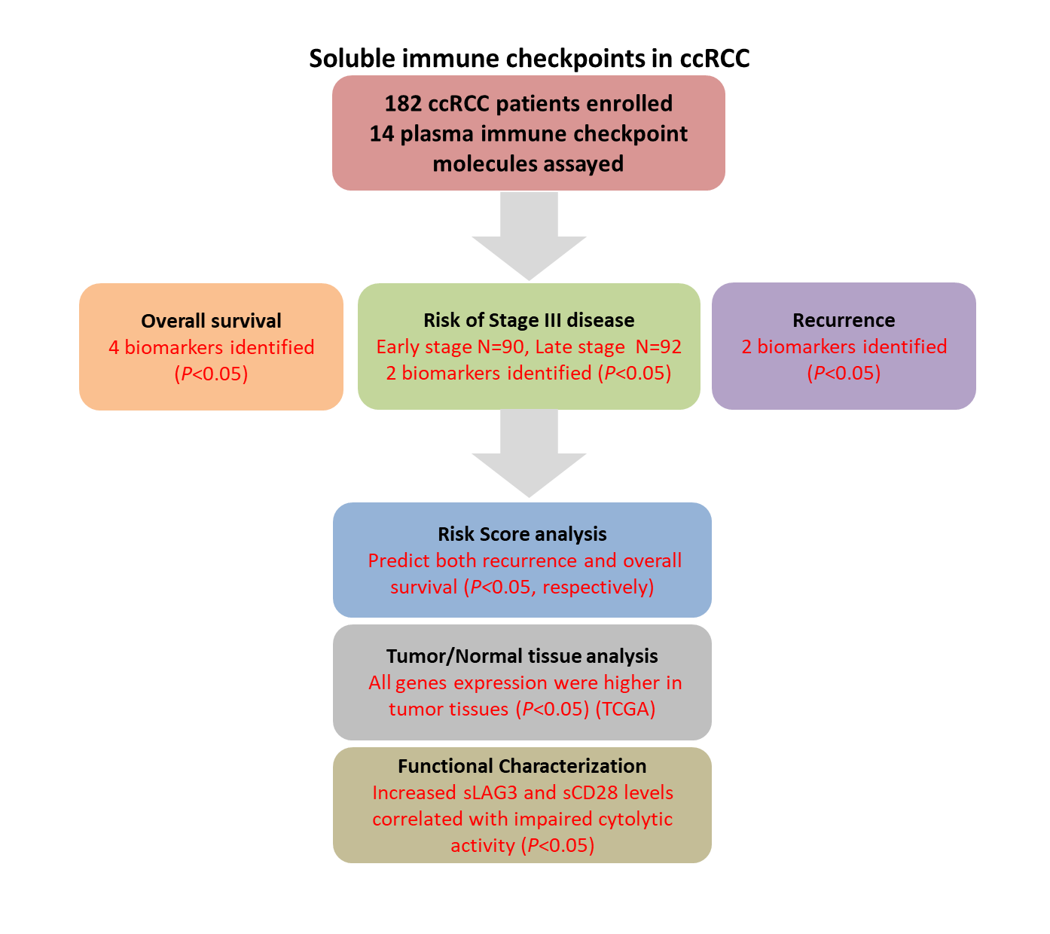

Supplemental Figure S1. Schematic design of the study

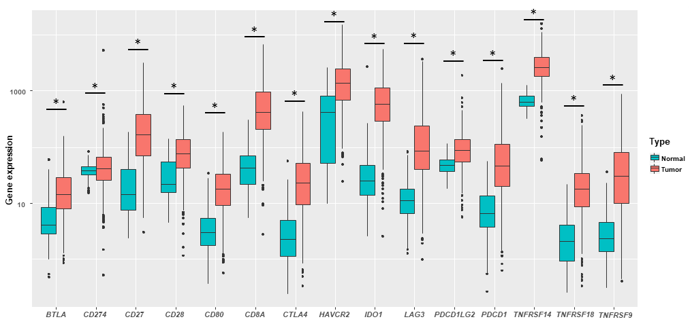

Supplemental Figure S2. Tumor and normal tissue expression of immune checkpoint genes in ccRCC patients derived from TCGA database. Maroon boxplot indicates tumor tissues (N=533), and green boxplot indicates normal tissues (N=72). Wilcoxon rank sum test was used in the comparison analysis. *indicates P<0.05.

