Figure S-1 Early Tumor Size Changes Cut-off Based on KEYNOTE-002 and -006
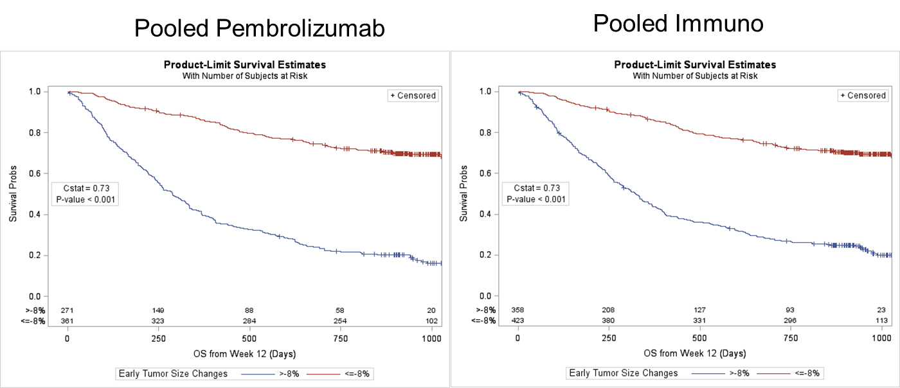

“Pooled Immuno” means pooling pembrolizumab and ipilimumab.

